Domain analysis

**Domain definition**:

The domain is “fashion inventory management”, the motivation of this domain analysis is to meliorate inventory management upon the existing systems and the native QR code detection, with increase in on-line sales as an outgrowth, for the fashion retailer *WEARTHIS*.

**General knowledge, terminology and methodology about the domain**:

*Inventory management*

The supervision of non-capitalized assets (inventory) and stock items. Inventory management supervises the flow of goods from manufacturers to warehouses and from these facilities to point of sale. Simply, it’s about having the right inventory at the right quantity, in the right place, at the right time, and at the right cost.

Inventory management system

System that tracks inventory movement across all sales channels in real time.

*Inventory management technique*

*Just in time (JIT)*: The method lessen the volume of inventory that a business have. Only purchase inventory a few days before it is needed.

*ABC analysis*: The method based on the Pareto Principle, different inventories are prepared according to the price/value of the item.

*Dropshipping*: This method directly transfer customer orders and shipment details to manufacturer or wholesaler, who then ships the goods directly to customers.

*Economic Order Quantity*

The Economic Order Quantity (EOQ) is the number of units that a company should add to inventory with each order to minimize the total costs of inventory.

It is given by:

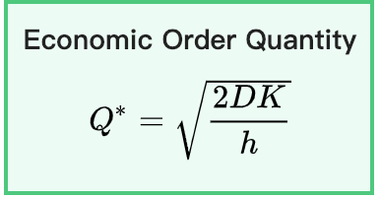

Where *D =* annual demand quantity, *K* = annual fixed cost (not per units), *h* = annual holding cost per unit.

*Backorder*

*Backorder* is an order for a good or service that cannot be filled at the current time due to a lack of available supply. *Backorder costs* include cost incurred by a business when it is unable to fill an order and must complete it later, usually computed and displayed on a per-unit basis.

*EU Regulation 1007/2011*

*EU Regulation 1007/2011* specified rules about labelling textile products information.

When developing search or ordering features there are noticeable requirements:

1. expressions “100%”, “pure” and “all” should be considered as the same, without other similar expression are allowed to be used.
2. “Wool” product should have further derivatives such as “fleece wool”, “virgin wool”, and same for other materials.
3. The expression of a material may also be referred to the indication of its composition.
4. Textile products containing two or more textile components of two or more different textile fibers must bear a label stating the fiber composition of each component.

Further details might refer to the regulation guidance:

https://assets.publishing.service.gov.uk/government/uploads/system/uploads/attachment_data/file/513963/BIS-16-193-textile-labelling-regulations-guidance.pdf

**Customers, users and stakeholders**:

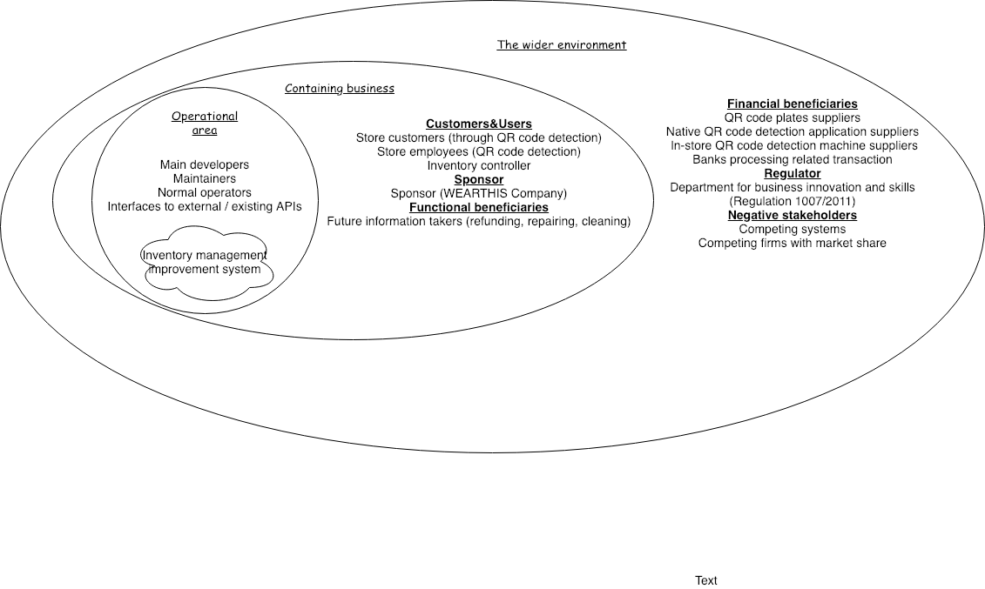

**Data and standard analysis**:

The aim of this data analysis is to find statistical evidences which give a rough idea about some problems might be facing.

Maximum request rate approximation

This approximation use resource from real-world clothing shops statistics.

How it is done: Taken the annual sales / revenue within the UK market from three large clothing retailer --- H&M, Next, Newlook --- then dividing by factors according to assumptions made:

1. Assuming every order has price from 0 to 100 pounds and taking the average 50.
2. Assuming the daily working hours are 10 hours.
3. Assuming that all the sales / revenue come from in-store purchases.
4. Assuming our system are going to cover all of the in-store purchases as maximum.
5. Assuming that each purchasing process contains 10 requests to the CPU.

|  |  |  |  |  |  |
| --- | --- | --- | --- | --- | --- |
| Retailers | Annual sales / revenue (Millions) | Annual working Second | Price per order | Maximum visiting rate (per second) | Maximum request rate (per second) |
| Next (2016) | 2374 | 365 * 10 *3600 = 13140000 | 50 | 4 | 40 |
| Next (2017) | 2305 | 13140000 | 50 | 4 | 40 |
| H&M (2016) | 15058 | 13140000 | 50 | 23 | 230 |
| H&M (2017) | 14580 | 13140000 | 50 | 22 | 230 |
| Newlook (2016) | 1491 | 13140000 | 50 | 2 | 20 |
| Newlook (2017) | 1455 | 13140000 | 50 | 2 | 20 |

( https://www.nextplc.co.uk/~/media/Files/N/Next-PLC-V2/documents/2017/Copy%20of%20WEBSITE%20FINAL%20PDF.pdf

<https://about.hm.com/content/dam/hmgroup/groupsite/documents/en/Annual%20Report/Annual%20Report%202017.pdf>

<https://www.newlookgroup.com/system/files/uploads/financialdocs/fy17-annual-report-06-06-2017.pdf>)

As it shown, the maximum estimated request rate (per second) stays under 250 request per second, but the safe position for our system will be determined only after concrete tests such as load test or actual performance test. Necessary cascading failure prevention should also be applied to the system.

Sizes conversion between clothing standards

Sizes conversion can be found on: <https://www.sizeguide.net>

Quote date: 2019.02.06